|  |
| --- |
| **Software Test Plan** |

|  |  |
| --- | --- |
| Nr. : | 01 |
| Title: | OS Scheduler |

**Contents**

1. Test Specification Information 3

2. Module Test Cases 3

3. Integration Test Cases 3

4. Naming rules for functions 3

# Test Specification Information

|  |  |  |
| --- | --- | --- |
| **Date of issue (MM/DD/YY)** | **Test Developer** | **Revision & Description** |
| 11/03/2014 | Esteban, Miguel | 1.0 |
|  |  |  |
|  |  |  |
|  |  |  |
|  |  |  |
|  |  |  |

# Module Test Cases

|  |  |  |
| --- | --- | --- |
| **Test Case** | **ID** | **Status** |
|  | **1.0** |  |
| **Requirements covered** | | |
| 1.1 | | |
| **Test Procedure** | | |
| Scheduler initialization shall be supported through SchM_Init API | | |
| **Expected Results** | | |
| Initialization of Scheduler via SchM_Init. | | |
| **Actual Results** | | **Test Results** |
| Scheduler is initialized by SchM_Init API | | PASS |
| **Comments** | | |
| Parameters are not supported currently since there not stack allocation. See Figure 1 | | |

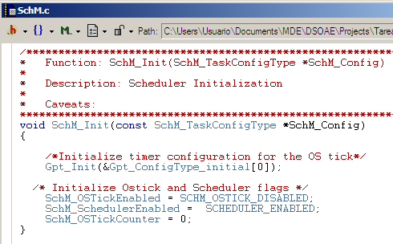

Figure 1

|  |  |  |
| --- | --- | --- |
| **Test Case** | **ID** | **Status** |
|  | **1.1** |  |
| **Requirements covered** | | |
| 1.2 | | |
| **Test Procedure** | | |
| Scheduler De-Initialization shall be supported through SchM_DeInit API | | |
| **Expected Results** | | |
| De-Initialization of Scheduler via SchM_DeInit | | |
| **Actual Results** | | **Test Results** |
| Scheduler is De-Initialized by SchM_DeInit API | | PASS |
| **Comments** | | |
| Only De-Initialization Scheduler flag is updated since there are not resources to de-initialize. See Figure 2 | | |

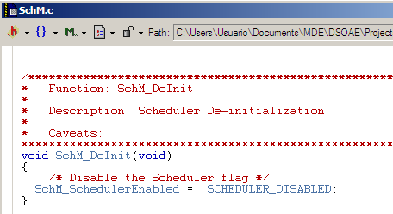

Figure 2

|  |  |  |
| --- | --- | --- |
| **Test Case** | **ID** | **Status** |
|  | **1.2** |  |
| **Requirements covered** | | |
| 1.3 | | |
| **Test Procedure** | | |
| Scheduler Start shall be supported through SchM_Start API | | |
| **Expected Results** | | |
| Start of the Scheduler via SchM_Start API | | |
| **Actual Results** | | **Test Results** |
| Scheduler is started by SchM_Start API | | PASS |
| **Comments** | | |
| See Figure 3. | | |

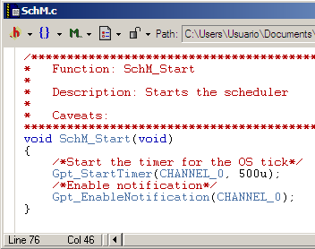

Figure 3

|  |  |  |
| --- | --- | --- |
| **Test Case** | **ID** | **Status** |
|  | **1.3** |  |
| **Requirements covered** | | |
| 1.4 | | |
| **Test Procedure** | | |
| OS Tick Callback shall be supported through SchM_OsTick API | | |
| **Expected Results** | | |
| OS Tick Callback support via SchM_OsTick API | | |
| **Actual Results** | | **Test Results** |
| OS Tick Callback is supported by SchM_OsTick API | | PASS |
| **Comments** | | |
| See Figure 4 | | |

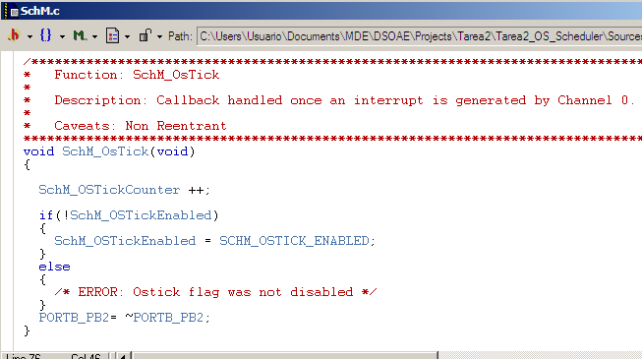

Figure 4

|  |  |  |
| --- | --- | --- |
| **Test Case** | **ID** | **Status** |
|  | **1.4** |  |
| **Requirements covered** | | |
| 1.5 | | |
| **Test Procedure** | | |
| Background task shall be supported through SchM_Background API | | |
| **Expected Results** | | |
| Background task support via SchM_Background API | | |
| **Actual Results** | | **Test Results** |
| Background task is supported by SchM_Background API | | PASS |
| **Comments** | | |
| See Figure 5 | | |

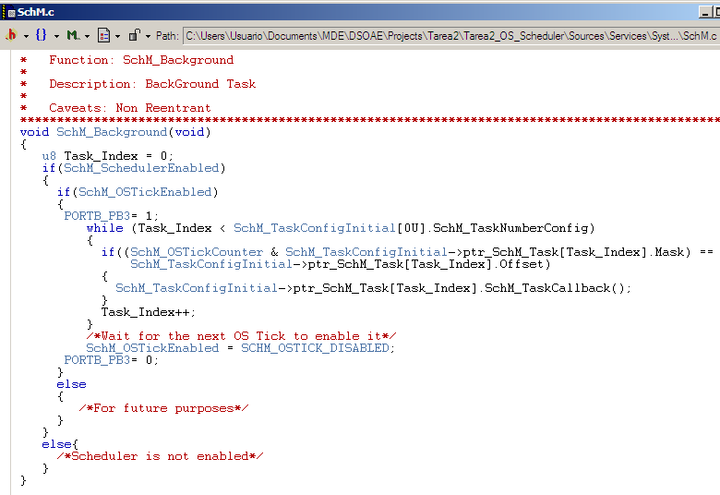

Figure 5

|  |  |  |
| --- | --- | --- |
| **Test Case** | **ID** | **Status** |
|  | **1.5** |  |
| **Requirements covered** | | |
| 1.6 | | |
| **Test Procedure** | | |
| Callback functions shall be referred as per the task period:  SchM_Task_##period(void) E.g. SchM_Task_1p56ms(void) | | |
| **Expected Results** | | |
| Callback functions referred as per the task period | | |
| **Actual Results** | | **Test Results** |
| Callback functions are referred as per the task period | | PASS |
| **Comments** | | |
| See Figure 6 | | |

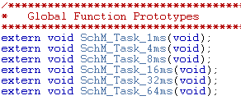

Figure 6

|  |  |  |
| --- | --- | --- |
| **Test Case** | **ID** | **Status** |
|  | **1.6** |  |
| **Requirements covered** | | |
| 1.9 | | |
| **Test Procedure** | | |
| Scheduler Module Shall be allocated at BSW and Services layer from AUTOSAR | | |
| **Expected Results** | | |
| Scheduler module allocated at BSW and Services layer from AUTOSAR | | |
| **Actual Results** | | **Test Results** |
| Scheduler module is allocated at BSW and Services layer from AUTOSAR | | PASS |
| **Comments** | | |
| See Figure 7 | | |

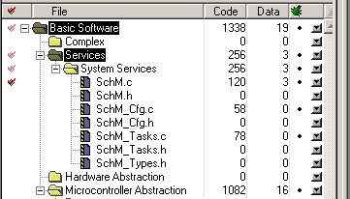

Figure 7

|  |  |  |
| --- | --- | --- |
| **Test Case** | **ID** | **Status** |
|  | **1.7** |  |
| **Requirements covered** | | |
| 1.11 | | |
| **Test Procedure** | | |
| SchM_Cfg.c & SchM_Cfg.h shall provide the task configuration table | | |
| **Expected Results** | | |
| Task configuration table provided in SchM_Cfg.c & SchM_Cfg.h | | |
| **Actual Results** | | **Test Results** |
| Task configuration table is included in SchM_Cfg.c & SchM_Cfg.h | | PASS |
| **Comments** | | |
| See Figure 8 & Figure 9 | | |

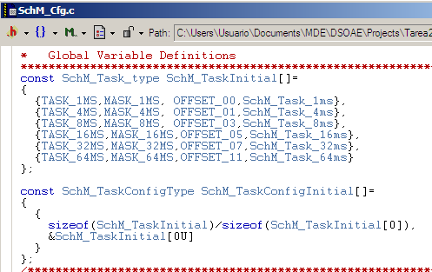

Figure 8

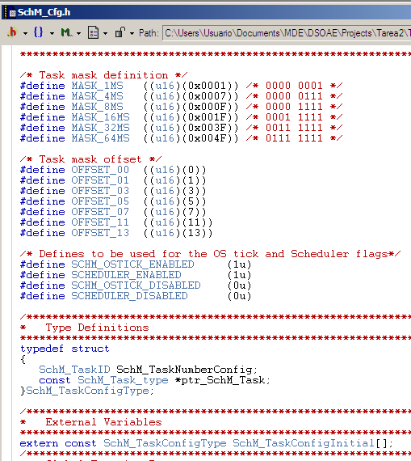

Figure 9

|  |  |  |
| --- | --- | --- |
| **Test Case** | **ID** | **Status** |
|  | **1.8** |  |
| **Requirements covered** | | |
| 1.12 | | |
| **Test Procedure** | | |
| SchM.c & SchM.h shall provide the main functionality of the Scheduler. OS-Tick callback shall be allocated in these files | | |
| **Expected Results** | | |
| Main functionality placed in SchM.c & SchM.h | | |
| **Actual Results** | | **Test Results** |
| Main functionality is allocated in SchM.c & SchM.h | | PASS |
| **Comments** | | |
| See Figure 10, Figure 11 & Figure 12 | | |

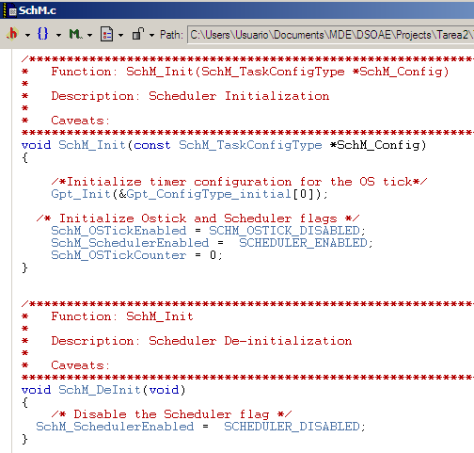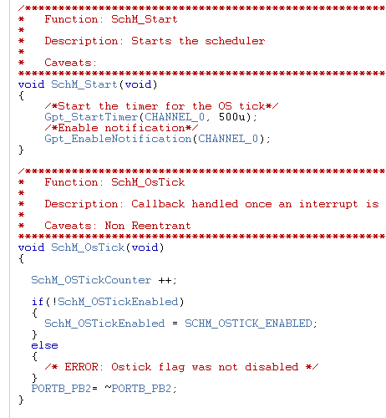

Figure 10

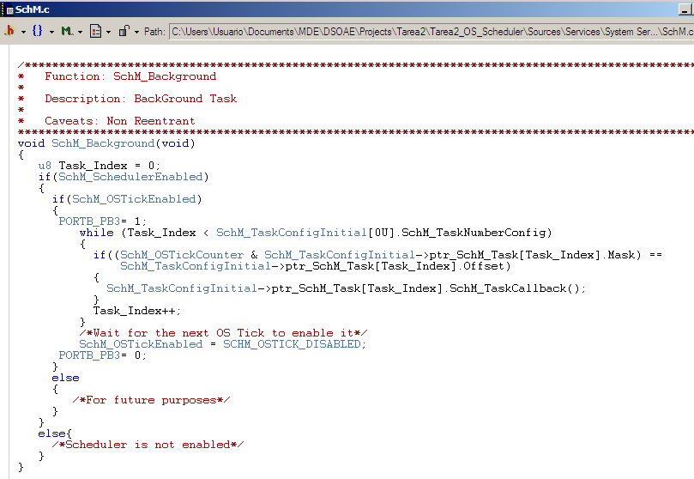

Figure 11

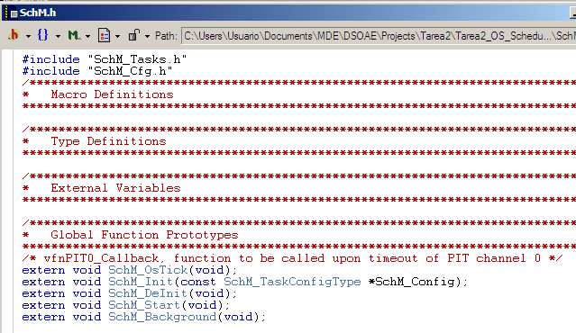

Figure 12

|  |  |  |
| --- | --- | --- |
| **Test Case** | **ID** | **Status** |
|  | **1.9** |  |
| **Requirements covered** | | |
| 1.13 | | |
| **Test Procedure** | | |
| SchM_Types.h shall provide the Scheduler type definitions | | |
| **Expected Results** | | |
| Scheduler type definitions included in SchM_Types.h | | |
| **Actual Results** | | **Test Results** |
| Scheduler type definitions are included in SchM_Types.h | | PASS |
| **Comments** | | |
| See Figure 13 | | |

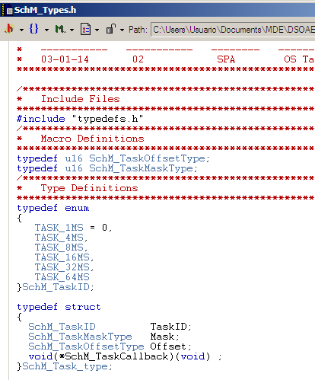

Figure 13

|  |  |  |
| --- | --- | --- |
| **Test Case** | **ID** | **Status** |
|  | **1.10** |  |
| **Requirements covered** | | |
| 1.14 | | |
| **Test Procedure** | | |
| SchM_Tasks.c & SchM_Tasks.h shall allocate the module's periodic tasks | | |
| **Expected Results** | | |
| Allocation of the periodic Tasks in SchM_Tasks.c & SchM_Tasks.h | | |
| **Actual Results** | | **Test Results** |
| Periodic Tasks are allocated in SchM_Tasks.c & SchM_Tasks.h | | PASS |
| **Comments** | | |
| See Figure 14, Figure 15 & Figure 16 | | |

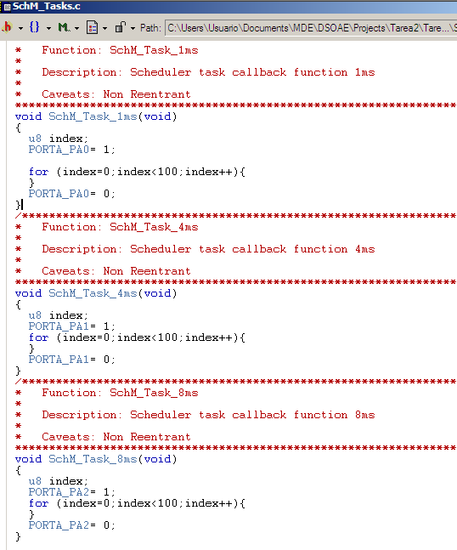

Figure 14

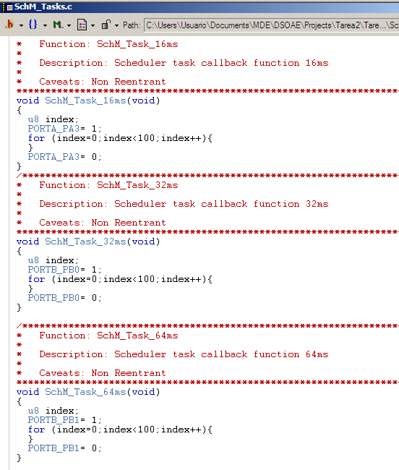

Figure 15

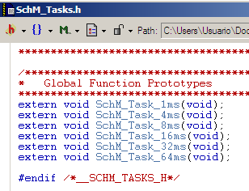

Figure 16

# Integration Test Cases

|  |  |  |
| --- | --- | --- |
| **Test Case** | **ID** | **Status** |
|  | **1.11** |  |
| **Requirements covered** | | |
| 1.15 | | |
| **Test Procedure** | | |
| Turn a Pin level ON at the entrance of a task and turn the Pin level OFF at the end of a task execution | | |
| **Expected Results** | | |
| Using an oscilloscope verify that every Task is working at the specified period | | |
| **Actual Results** | | **Test Results** |
| **TBD** | | PASS |
| **Comments** | | |
|  | | |

|  |  |  |
| --- | --- | --- |
| **Test Case** | **ID** | **Status** |
|  | **1.12** |  |
| **Requirements covered** | | |
| 1.16 | | |
| **Test Procedure** | | |
| Turn a pin level ON before entering the Background Task and turn the pin level OFF at the end of the Background Task | | |
| **Expected Results** | | |
| Using an oscilloscope verify the CPU Load at the specified pin level | | |
| **Actual Results** | | **Test Results** |
| **TBD** | | PASS |
| **Comments** | | |
|  | | |

|  |  |  |
| --- | --- | --- |
| **Test Case** | **ID** | **Status** |
|  | **1.13** |  |
| **Requirements covered** | | |
| 1.17 | | |
| **Test Procedure** | | |
| Modify the CPU Load by adding workload to the tasks | | |
| **Expected Results** | | |
| Using an oscilloscope verify the CPU Load at the specified pin level | | |
| **Actual Results** | | **Test Results** |
| **TBD** | | PASS |
| **Comments** | | |
|  | | |